|  |  |
| --- | --- |
| *Pacific Gas and Electric Company* | |
| Release 9.7.2 Installation Guide | |
|  |  |
|  |  |
| Project | ED AM/GIS |
|  |  |
| Prepared by | Subhankar Baidya |
| Date | 9/10/2015 |
| Version | 1.0 |
| Version Type | Draft |

|  |  |  |  |
| --- | --- | --- | --- |
| Revision History | | | |
| Document # | Date | Author | Summary of Changes |
| 1.0 | 8/10/2015 | Rob Rader | Initial Document Creation |
|  |  |  |  |

# Introduction

## Purpose

This document is intended to detail the implementation and configuration steps required to implement Release 9.7.2 Installation Guide. This document describes the various configuration aspects required to complete any manual or automatic patch associated with this release. Each section in this document contains the steps required to patch the system in production.

## Terms Used

|  |  |
| --- | --- |
| OOTB | Out of the box. Unmodified from the commercial version. |
| TFS | Team Foundation Server |

## External Documents

Referenced are any external configuration documents or exports. These are documents that contain more detailed information about configuring a system or documents that can be loaded into an application to perform the configuration detailed in this document.

1. Supporting documentation folder
   1. **TFS documentation location:**

$/EDAMGIS/Source_Development_10_2_1/Documentation/Data Model/Release Documentation/EDER/9.7.2

## List of Fixes

Below is the list of change requests detailing all fixes for the data model for this release:

|  |  |
| --- | --- |
| **Item Number** | **Title** |
| [23202](http://edappgistfsprd1:8080/tfs/ElectricDistCollection/EDAMGIS/_workitems/edit/23202) | Master TFS DM 9.7.2 |
| [23062](http://edappgistfsprd1:8080/tfs/ElectricDistCollection/EDAMGIS/_workitems/edit/23062) | Add GUID based SubsurfaceStructure foreign key field onto VaultPoly |
| [23195](http://edappgistfsprd1:8080/tfs/ElectricDistCollection/EDAMGIS/_workitems/edit/23195) | Update the DuctAnnotation feature class to use Standard Labeling Engine in system test |
| [23199](http://edappgistfsprd1:8080/tfs/ElectricDistCollection/EDAMGIS/_workitems/edit/23199) | Update Map Multiplier from 16 to 12 inches |
| [23252](http://edappgistfsprd1:8080/tfs/ElectricDistCollection/EDAMGIS/_workitems/edit/23252) | Turn on 50 scale annotation by default |
| [23261](http://edappgistfsprd1:8080/tfs/ElectricDistCollection/EDAMGIS/_workitems/edit/23261) | Uplift all phase designations for conduit system relationships that are null to support 10.2.1 |
| [23268](http://edappgistfsprd1:8080/tfs/ElectricDistCollection/EDAMGIS/_workitems/edit/23268) | Update Duct indicator aliases |
| [23317](http://edappgistfsprd1:8080/tfs/ElectricDistCollection/EDAMGIS/_workitems/edit/23317) | SAP Equipment Number needs to be made visible |
| [23272](http://edappgistfsprd1:8080/tfs/ElectricDistCollection/EDAMGIS/_workitems/edit/23272) | Add New Field SAPSortField to OpenPoint |
| [23269](http://edappgistfsprd1:8080/tfs/ElectricDistCollection/EDAMGIS/_workitems/edit/23269) | Add New Attribute SAPSortField to Switch |
| [23294](http://edappgistfsprd1:8080/tfs/ElectricDistCollection/EDAMGIS/_workitems/edit/23294) | Add Members to the Device Manufacture Domain (for IVARA) |
| [23296](http://edappgistfsprd1:8080/tfs/ElectricDistCollection/EDAMGIS/_workitems/edit/23296) | Assign Device Manufacturer Domain to NetworkProtector.Manufacturer |
| [23297](http://edappgistfsprd1:8080/tfs/ElectricDistCollection/EDAMGIS/_workitems/edit/23297) | Assign the Domain Installation Type to the NetworkProtector InstallCode Attribute |
| [23298](http://edappgistfsprd1:8080/tfs/ElectricDistCollection/EDAMGIS/_workitems/edit/23298) | Add New Domain "Protector Type" |
| [23299](http://edappgistfsprd1:8080/tfs/ElectricDistCollection/EDAMGIS/_workitems/edit/23299) | Assign the Protector Type Domain to NetworkProtector.ProtectorType Attribute |
| [23300](http://edappgistfsprd1:8080/tfs/ElectricDistCollection/EDAMGIS/_workitems/edit/23300) | Create New Domain "Protector Voltage" |
| [23301](http://edappgistfsprd1:8080/tfs/ElectricDistCollection/EDAMGIS/_workitems/edit/23301) | Assign the Domain "Protector Voltage" to the NetworkProtector.ProtectorVoltage Attribute |
| [23302](http://edappgistfsprd1:8080/tfs/ElectricDistCollection/EDAMGIS/_workitems/edit/23302) | Add New Domain "Nameplate Amperage" |
| [23303](http://edappgistfsprd1:8080/tfs/ElectricDistCollection/EDAMGIS/_workitems/edit/23303) | Assign the Domain "Nameplate Amperage" to NetworkProtector.NameplateAmperage Attribute |
| [23305](http://edappgistfsprd1:8080/tfs/ElectricDistCollection/EDAMGIS/_workitems/edit/23305) | Add New Domain "Fuse Type" |
| [23306](http://edappgistfsprd1:8080/tfs/ElectricDistCollection/EDAMGIS/_workitems/edit/23306) | Assign "Fuse Type" Domain to the NetworkProtector.FuseType Attribute |
| [23307](http://edappgistfsprd1:8080/tfs/ElectricDistCollection/EDAMGIS/_workitems/edit/23307) | Add New Domain "NP Relay Type" |
| [23308](http://edappgistfsprd1:8080/tfs/ElectricDistCollection/EDAMGIS/_workitems/edit/23308) | Assign the Domain "NP Relay Type" to the NetworkProtector.RelayType Attribute |
| [23320](http://edappgistfsprd1:8080/tfs/ElectricDistCollection/EDAMGIS/_workitems#_a=edit&id=23320) | Remove ArcFM Check Cross Section AU from Pri/Sec/DC |
| [23324](http://edappgistfsprd1:8080/tfs/ElectricDistCollection/EDAMGIS/_workitems/edit/23324) | Assign the Domain Installation Type to the TransformerDevice subtype Primary Connection Chamber InstallCode attribute |
| [23356](http://edappgistfsprd1:8080/tfs/ElectricDistCollection/EDAMGIS/_workitems/edit/23356) | SAPSORTFIELD needs to be made visible in TransformerDevice table |
|  |  |

Contents

1 Introduction 3

1.1 Purpose 3

1.2 Terms Used 3

1.3 External Documents 3

1.4 List of Fixes 4

2 EDGIS 7

2.1 Open a Database Connection in ArcCatalog 7

2.2 23062: Add GUID based SubsurfaceStructure foreign key field onto VaultPoly 8

2.3 23195: Update the DuctAnnotation feature class to use Standard Labeling Engine in system test 19

2.4 23199: Update Map Multiplier from 16 to 12 inches 20

2.5 23252: Turn on 50 scale annotation by default 21

2.6 23261: Uplift all phase designations for conduit system relationships that are null to support 10.2.1 22

2.7 23268: Update Duct indicator aliases 24

2.8 23317: SAP Equipment Number needs to be made visible 26

2.9 23272: Add New Field SAPSortField to OpenPoint 30

2.10 23269: Add New Attribute SAPSortField to Switch 31

2.11 23294: Add Members to the Device Manufacture Domain (for IVARA) 32

2.12 23296: Assign Device Manufacturer Domain to NetworkProtector.Manufacturer 33

2.13 23297: Assign the Domain Installation Type to the NetworkProtector InstallCode Attribute 34

2.14 23298: Add New Domain "Protector Type" 35

2.15 23299: Assign the Protector Type Domain to NetworkProtector.ProtectorType Attribute 36

2.16 23300: Create New Domain "Protector Voltage" 37

2.17 23301: Assign the Domain "Protector Voltage" to the NetworkProtector.ProtectorVoltage Attribute 38

2.18 23302: Add New Domain "Nameplate Amperage" 39

2.19 23303: Assign the Domain "Nameplate Amperage" to NetworkProtector.NameplateAmperage Attribute 41

2.20 23305: Add New Domain "Fuse Type" 42

2.21 23306: Assign "Fuse Type" Domain to the NetworkProtector.FuseType Attribute 43

2.22 23307: Add New Domain "NP Relay Type" 44

2.23 23308: Assign the Domain "NP Relay Type" to the NetworkProtector.RelayType Attribute 45

2.24 23320: Remove ArcFM Check Cross Section AU from Pri/Sec/DC 46

2.25 23324: Assign the Domain Installation Type to the TransformerDevice subtype Primary Connection Chamber InstallCode attribute 47

2.26 23356: SAPSORTFIELD needs to be made visible in TransformerDevice table 48

2.27 Update Data Model Version Table 49

3 Known Issues 50

# EDGIS

## Open a Database Connection in ArcCatalog

1. Open ArcCatalog.
2. Within the Catalog Tree, expand “Database Connections” and open the active connection for this process. This is the connection that is referenced in the change request associated with this document (<DB name>). If this connection does not exist, create the connection as the EDGIS user and alter the name to the format specified.

## 23062: Add GUID based SubsurfaceStructure foreign key field onto VaultPoly

1. Get exclusive access to EDGIS user.
2. Navigate to VaultPoly feature class. Double clickmon it to open properties window. Add "SUBSTRUCTGUID" field of type GUID to VaultPoly

Name: STRUCTUREGUID

Alias: Structure GUID

Type: GUID

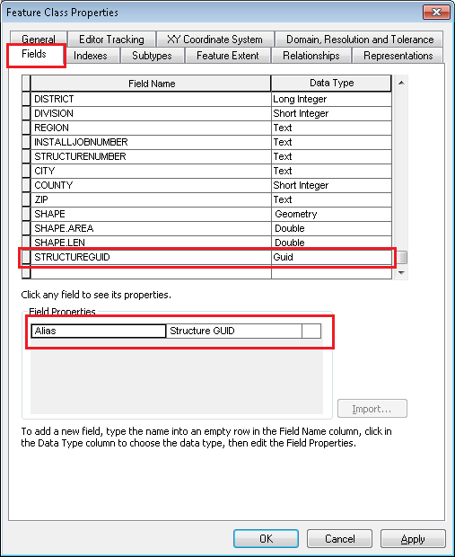

Click Apply. Click OK.

1. Add relationship class (Simple, 1-1) between the globalid field on subsurfacestructure and the new substructguid field on VaultPoly

Name: SubsurfaceStructure_VaultPoly  
Origin object class: EDGIS.SubsurfaceStructure  
Destination object class: EDGIS.VaultPoly  
Type: Simple  
Forward Path Label: Vault Polygon  
Backward Path Label: Subsurface Structure  
Message propagation: None (no messages propagated)  
Cardinality: 1 - 1  
Has attributes: No  
Origin Primary Key: GLOBALID  
Origin Foreign Key: STRUCTUREGUID

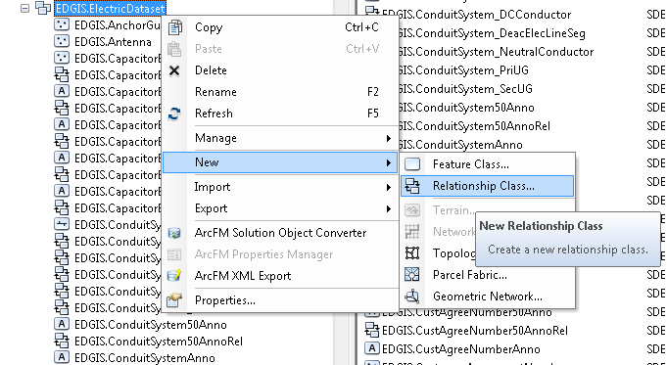

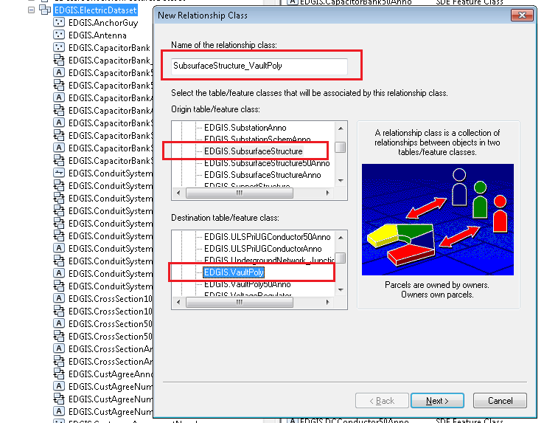

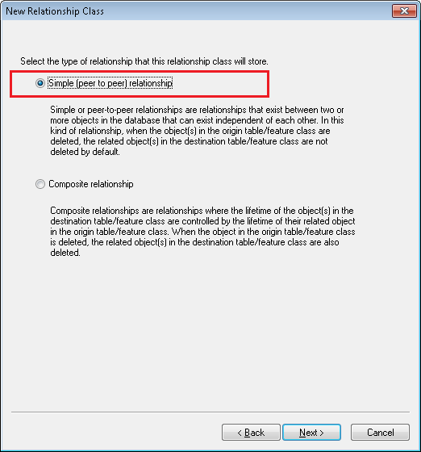

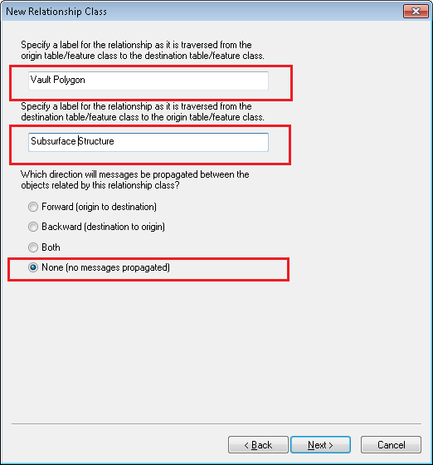

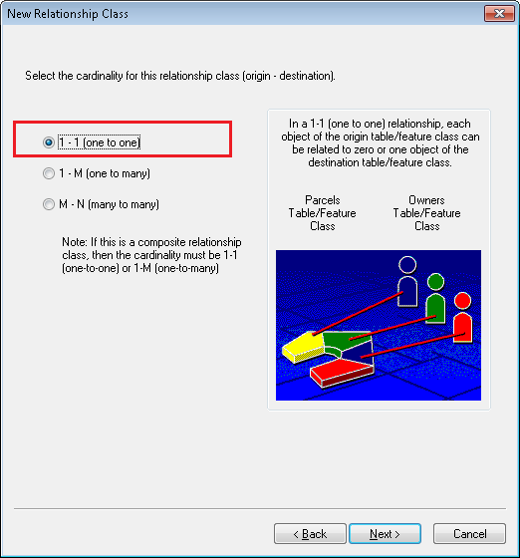

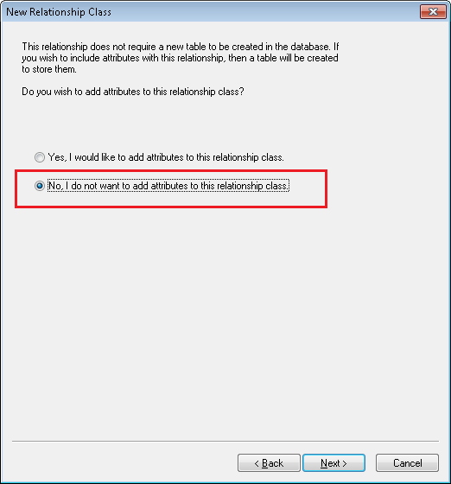

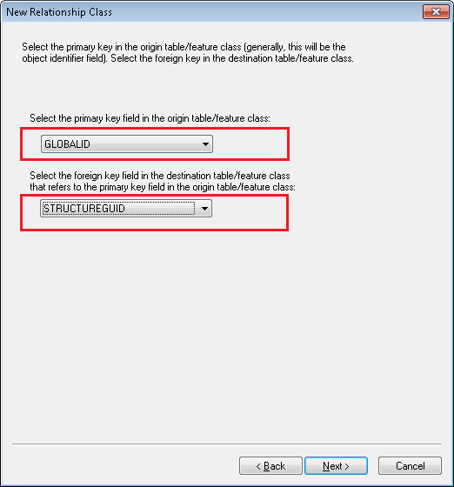

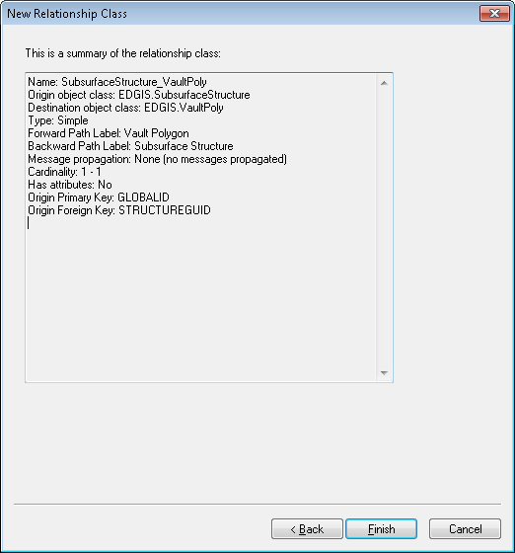

1. **Develop script to populate** SUBSTRUCTGUID on VaultPoly based on matches between the following fields present on both features:

Region

Division

StructureNumber

If a unique match cannot be found, do not update but output to a log file the OID's of the matches found.

Script path: \\sfetgis-nas01\sfgispoc_data\ApplicationDevelopment\IBM_Delivery\10.2.1\Releases\DataModel\9.7.2

File name: **???**

1. Add new model name, PGE_SUBSTRUCTGUID to the **PGE ED Field Model Name** domain. Click Apply. Click OK.

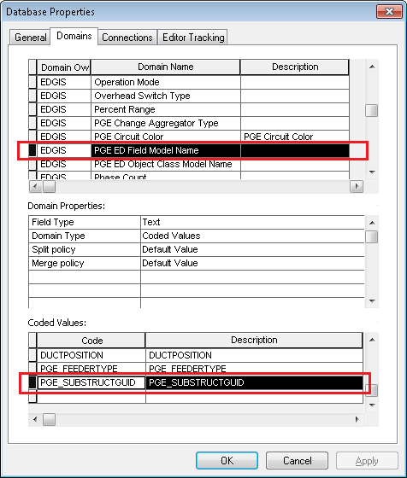

1. Right-click on the **VaultPoly** feature class and select ArcFM Properties Manager
2. Select the **Field Model Names** tab
3. Select the new SUBSTRUCTGUID field
4. Assign the PGE_SUBSTRUCTGUID field model name to the SUBSTRUCTGUID field
5. Click OK

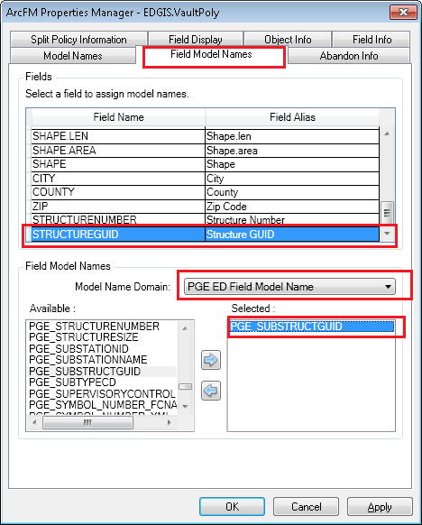

## 23195: Update the DuctAnnotation feature class to use Standard Labeling Engine in system test

Follow the steps below to convert the current DuctAnnotation feature class to use the standard Esri labeling engine.

1. In ArcCatalog menu: Customize🡪Customize Mode dialog, click on '**Add From File…**'  and select **ChangeAnnotationLabelEngine.dll** from the given path:

\\sfetgis-nas01\sfgispoc_data\ApplicationDevelopment\IBM_Delivery\10.2.1\Releases\DataModel\9.7.2

1. Press OK when the Added Objects prompt appears which will add the command to the dialog.
2. Under the Commands tab, select the "Change Annotation Feature Class Label Engine" command from the Developer Samples category, and drag it on to a toolbar. Dismiss the Customize dialog.

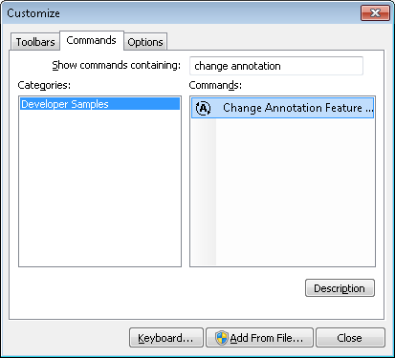

1. Connect to the desired database as the EDGIS user (must have exclusive access to the database)
2. Select the EDGIS.DuctAnnotation feature class

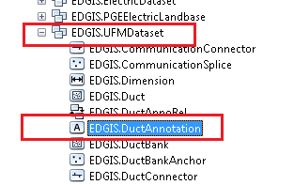

1. Click on the newly added command, and a dialog will appear. It will list the existing label engine being used (Maplex) and then the label engine that the properties will be converted to (Standard).
2. Press OK to convert the properties.
3. A message box will appear when the conversion is complete.

## 23199: Update Map Multiplier from 16 to 12 inches

1. Right-click on the database level node (root node) and select “ArcFM Properties Manager”
2. Select the Underground Facilities tab
3. Ensure the Duct Units is set to Inches
4. Update the Map Size Multiplier from 16 to 12
5. Click on OK

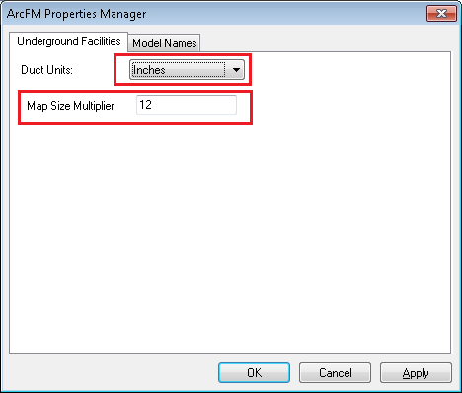

## 23252: Turn on 50 scale annotation by default

Modify the 50 scale annotation feature classes to create their annotation by default.

1. Right click on CapacitorBank50Anno and select Properties
2. Select the Annotation tab
3. Check Create annotation when new features are added
4. Check Update annotation when features shape is modified
5. Click OK

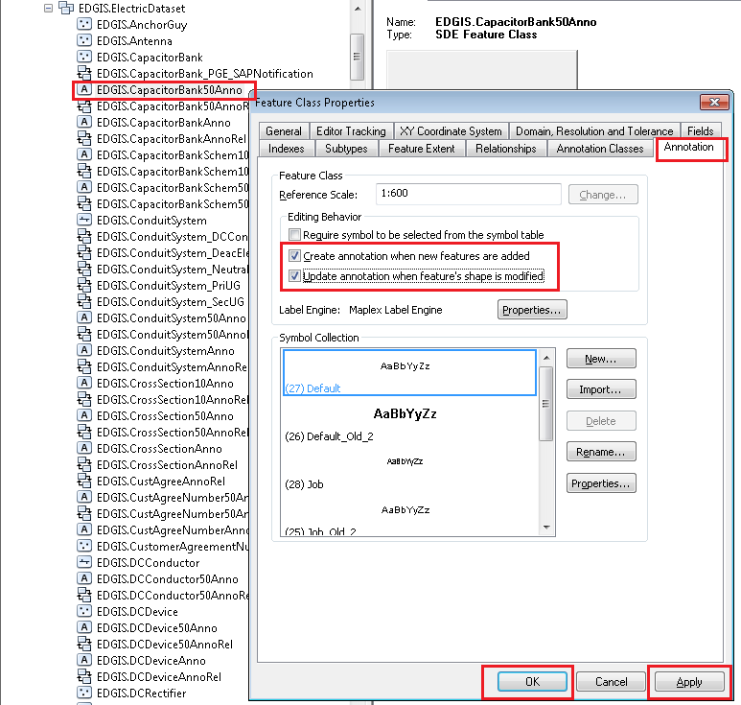

1. Repeat until all 50 scale anno classes are updated. Full list given below:

* CapacitorBank50Anno
* ConduitSystem50Anno
* CustAgreeNumber50Anno
* DCConductor50Anno
* DCDevice50Anno
* DCRectifier50Anno
* DeactivatedElecLineSeg50Anno
* DeliveryPoint50Anno
* DeviceGroup50Anno
* DistBusBar50Anno
* DynProtDevice50Anno
* FaultIndicator50Anno
* Fuse50Anno
* JobNumber50Anno
* NetworkProtector50Anno
* PrimaryGeneration50Anno
* PriOHConductor50Anno
* PriUGConductor50Anno
* SecOHConductor50Anno
* SecondaryGeneration50Anno
* SecUGConductor50Anno
* StepDown50Anno
* StreetLight50Anno
* Substation50Anno
* SubsurfaceStructure50Anno
* Switch50Anno
* Transformer50Anno
* VaultPoly50Anno
* VoltageRegulator50Anno

## 23261: Uplift all phase designations for conduit system relationships that are null to support 10.2.1

1. Connect to the database as the edgis user in SQLPLUS.
2. Make sure that the command prompt window has a history buffer of more than 1000 rows
3. Execute the sql file (**update_phasedesignation_for_conduitsystem_tophase_wherenull.sql**) given in below path in the SQLPLUS/SQL Developer window by copy and pasting it.

\\sfetgis-nas01\sfgispoc_data\ApplicationDevelopment\IBM_Delivery\10.2.1\Releases\DataModel\9.7.2

1. Create a new text file and copy the contents of the sqlplus run/output into it.
2. Attach the new text file to this TFS for review, so that the output can be confirmed as correct.
3. Execute the sql file (**update_phasedesignation_for_conduitsystem_to_1021supported_values.sql**) given in the above 9.7.2 path in SQLPLUS by copy/pasting it.
4. Create a new text file and copy the contents of the sqlplus run/output into it.
5. Attach the new text file to this TFS for review, so that the output can be confirmed as correct.

## 23268: Update Duct indicator aliases

Update the MISCIDC1 duct alias to read "Parallel Conductor Indicator".

1. Right click on the DUCTDEFINITION table and select properties
2. Select the Fields tab
3. Find the MISCIDC1 field
4. Modify the alias to "Parallel Conductor Indicator"

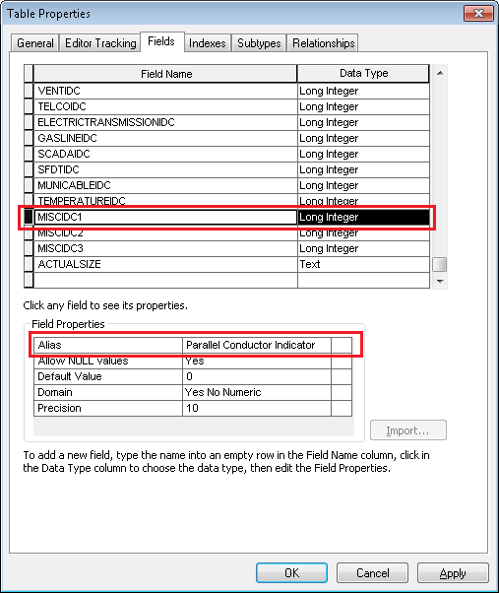

1. Click Apply. Click OK
2. Right click on the **Duct** feature class in the **UFM Dataset** and select properties
3. Select the Fields tab
4. Find the MISCIDC1 field
5. Modify the alias to "Parallel Conductor Indicator"

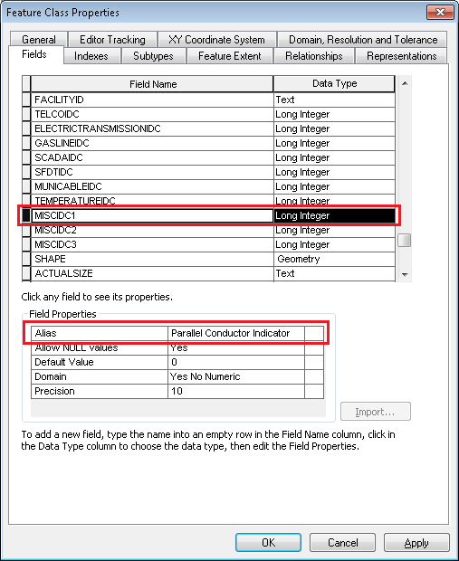

1. Click Apply. Click OK.

## 23317: SAP Equipment Number needs to be made visible

1. Open ArcCatalog
2. Right click on **NetworkProtector**. Select "ArcFM Properties Manager".
3. Go to "Field Info" tab. Select "SAPEQUIPID" field. Set Visible=Yes.

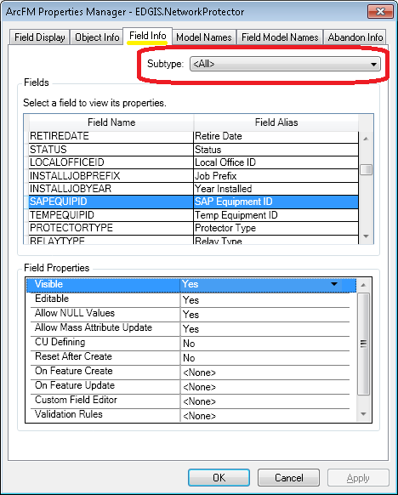

1. Click OK.
2. Right click on **Switch**. Select "ArcFM Properties Manager".
3. Go to "Field Info" tab.
4. Select "Ground Switch" subtype.
5. Select "SAPEQUIPID" field. Set Visible=Yes. Click Apply.

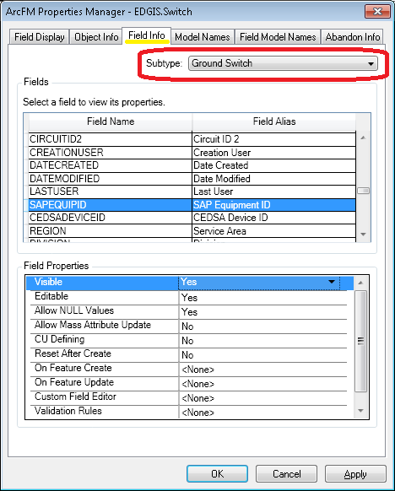

1. Select "Subsurface Switch" subtype.
2. Select "SAPEQUIPID" field. Set Visible=Yes. Click Apply.

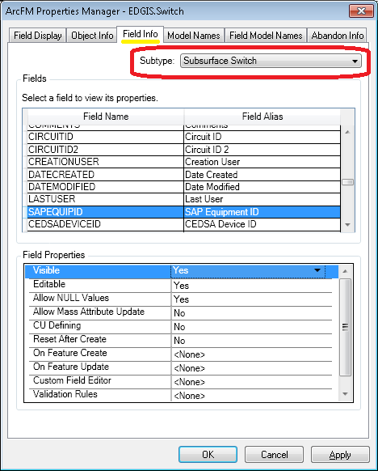

1. Click OK.
2. Right click on **TransformerUnit**. Select "ArcFM Properties Manager".
3. Go to "Field Info" tab. Select "SAPEQUIPID" field. Set Visible=Yes.

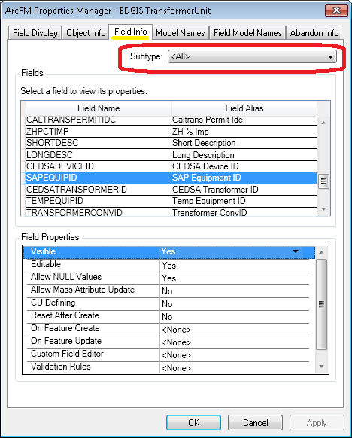

1. Click OK.

## 23272: Add New Field SAPSortField to OpenPoint

1. Get exclusive access to EDGIS user.
2. Navigate to OpenPoint feature class. Double click on it to open properties window. Add new attribute to OpenPoint

Name: SAPSORTFIELD

Alias: SAP Sort Field

String Length 50

Allow NULL values

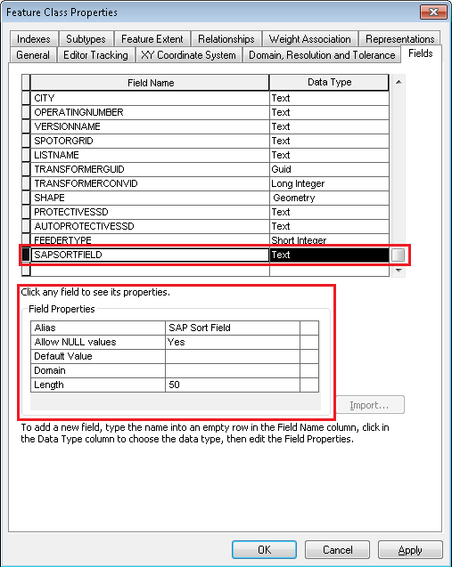

## 23269: Add New Attribute SAPSortField to Switch

1. Get exclusive access to EDGIS user.
2. Navigate to Switch feature class. Double click on it to open properties window. Add new attribute to Switch

Name: SAPSORTFIELD

Alias: SAP Sort Field

String Length 50

Allow NULL values



## 23294: Add Members to the Device Manufacture Domain (for IVARA)

1. Get exclusive access to EDGIS user.
2. Add the following new members to the Device Manufacturer domain:

Domain: Device Manufacturer

**Code** **Description**

A2 ABB

E2 Eaton Cutler-Hammer

CH Cutler-Hammer

RI Richards

W2 Westinghouse2

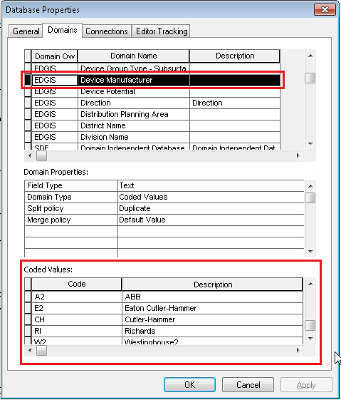

## 23296: Assign Device Manufacturer Domain to NetworkProtector.Manufacturer

1. Get exclusive access to EDGIS user.
2. Right click on NetworkProtector. Select “Properties…”.
3. Add Device Manufacturer domain to Manufacturer field.
4. Click Apply. Click OK.

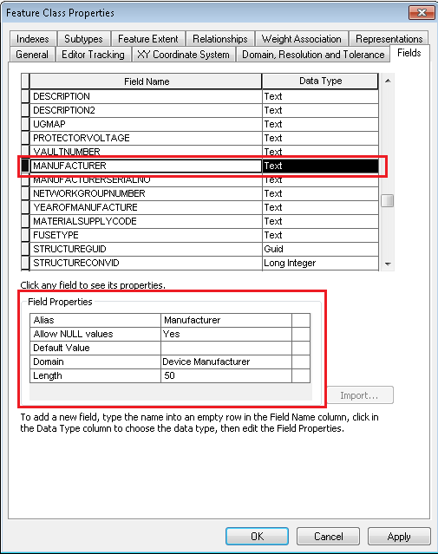

## 23297: Assign the Domain Installation Type to the NetworkProtector InstallCode Attribute

1. Get exclusive access to EDGIS user.
2. Right click on NetworkProtector. Select “Properties…”.
3. Add Installation Type domain to INSTALLCODE field.
4. Click Apply. Click OK.

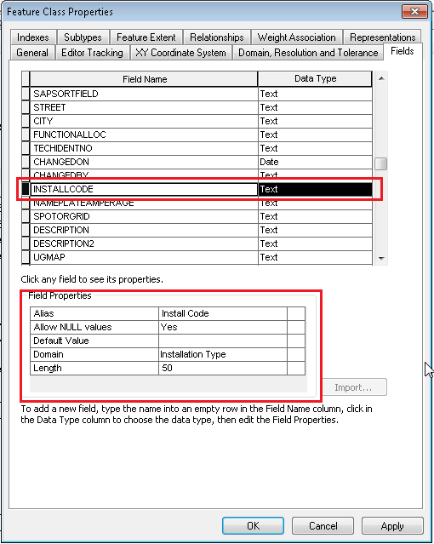

## 23298: Add New Domain "Protector Type"

1. Get exclusive access to EDGIS user.
2. Add new domain Protector Type.
3. Add the following new members to the Protector Type domain:

Domain Name: Protector Type

Field Type: Text

Domain Type: Coded Values

**Code** **Description**

CM22 CM-22

CM52 CM-52

CMD CMD

MG8 MG-8

NP113 NP113

NP313 NP313

NP315 NP315

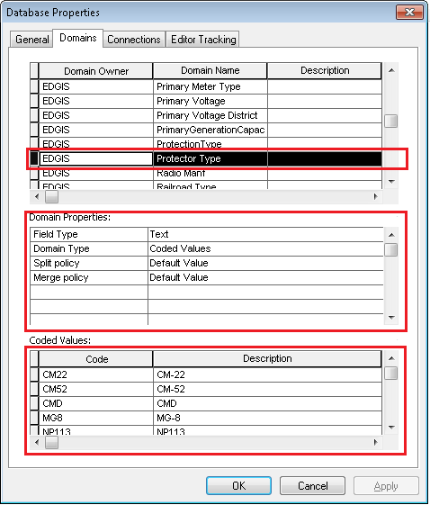

## 23299: Assign the Protector Type Domain to NetworkProtector.ProtectorType Attribute

1. Get exclusive access to EDGIS user.
2. Right click on NetworkProtector. Select “Properties…”.
3. Add Protector Type domain to PROTECTORTYPE field.
4. Click Apply. Click OK.

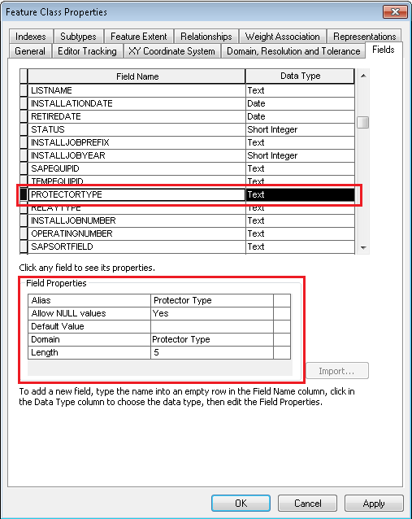

## 23300: Create New Domain "Protector Voltage"

1. Get exclusive access to EDGIS user.
2. Add new domain Protector Voltage.
3. Add the following new members to the Protector Voltage domain:

Domain Name: Protector Voltage

Field Type: Text

Domain Type: Coded Values

**Code** **Description**

AA 125/216V

BB 277/480V

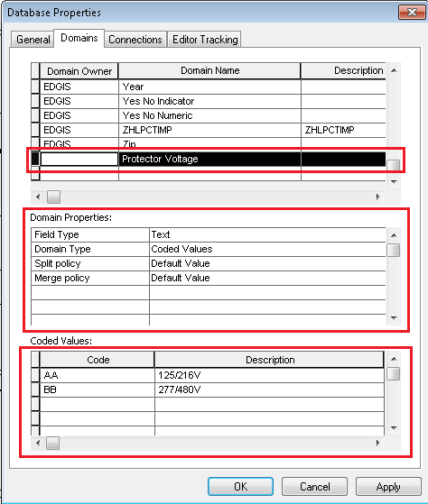

## 23301: Assign the Domain "Protector Voltage" to the NetworkProtector.ProtectorVoltage Attribute

1. Get exclusive access to EDGIS user.
2. Right click on NetworkProtector. Select “Properties…”.
3. Add Protector Voltage domain to PROTECTORVOLTAGE field.
4. Click Apply. Click OK.

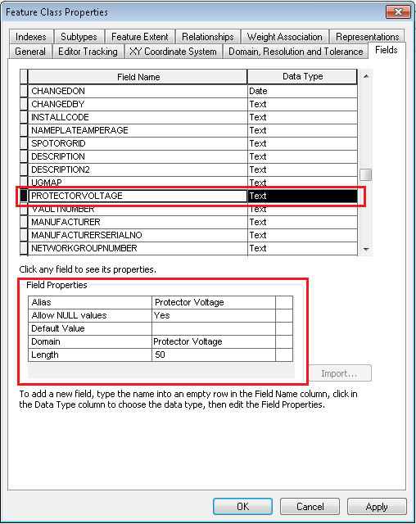

## 23302: Add New Domain "Nameplate Amperage"

1. Get exclusive access to EDGIS user.
2. Add new domain Nameplate Amperage.
3. Add the following new members to the Nameplate Amperage domain:

Domain Name: Nameplate Amperage

Field Type: Text

Domain Type: Coded Values

**Code** **Description**

1175 1175 AMPS

1200 1200 AMPS

1500 1500 AMPS

1600 1600 AMPS

1875 1875 AMPS

2325 2325 AMPS

2825 2825 AMPS

2826 2826 AMPS

3000 3000 AMPS

3500 3500 AMPS

800 800 AMPS

Unspecified Unspecified

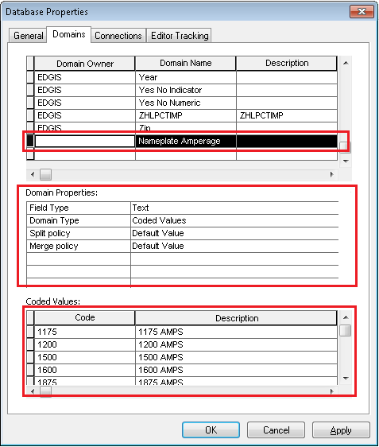

## 23303: Assign the Domain "Nameplate Amperage" to NetworkProtector.NameplateAmperage Attribute

1. Get exclusive access to EDGIS user.
2. Right click on NetworkProtector. Select “Properties…”.
3. Add Nameplate Amperage domain to NameplateAmperage field.
4. Click Apply. Click OK.

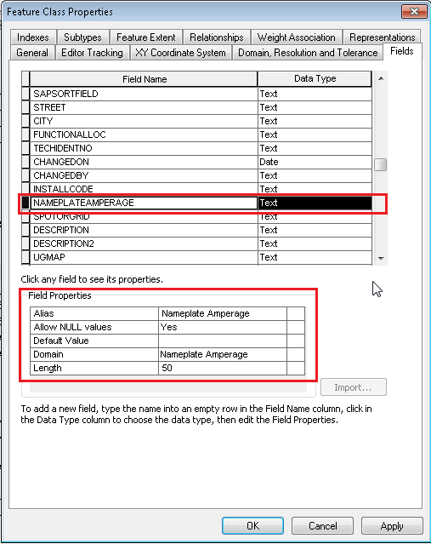

## 23305: Add New Domain "Fuse Type"

1. Get exclusive access to EDGIS user.
2. Add new domain Fuse Type.
3. Add the following new members to the Fuse Type domain:

Domain Name: Fuse Type

Field Type: Text

Domain Type: Coded Values

**Code** **Description**

EXTSILSAND External Silver/Sand Fuse

INTCOPLNK Internal Copper Link/Metal All

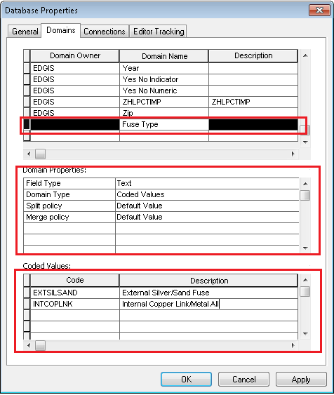

## 23306: Assign "Fuse Type" Domain to the NetworkProtector.FuseType Attribute

1. Get exclusive access to EDGIS user.
2. Right click on NetworkProtector. Select “Properties…”.
3. Add Fuse Type domain to FuseType field.
4. Click Apply. Click OK.

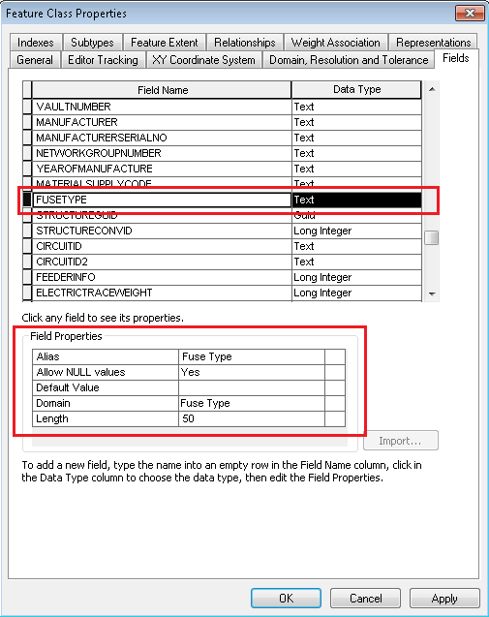

## 23307: Add New Domain "NP Relay Type"

1. Get exclusive access to EDGIS user.
2. Add new domain NP Relay Type.
3. Add the following new members to the NP Relay Type domain:

Domain Name: NP Relay Type

Field Type: Text

Domain Type: Coded Values

**Code** **Description**

EM Electromechanical

MP Microprocessor

SS Solid State

UNK Unknown

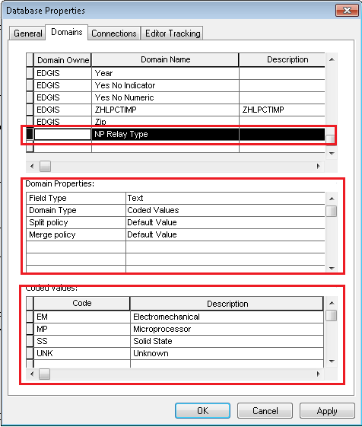

## 23308: Assign the Domain "NP Relay Type" to the NetworkProtector.RelayType Attribute

1. Get exclusive access to EDGIS user.
2. Right click on NetworkProtector. Select “Properties…”.
3. Add NP Relay Type domain to RelayType field.
4. Click Apply. Click OK.

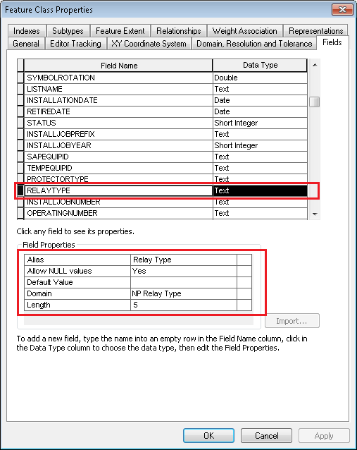

## 23320: Remove ArcFM Check Cross Section AU from Pri/Sec/DC

1. Right-click on PriUGConductor in the Electric Dataset and select ArcFM Properties Manager
2. Select the Object Info tab
3. From the On Feature Update event pulldown, select Multiple...

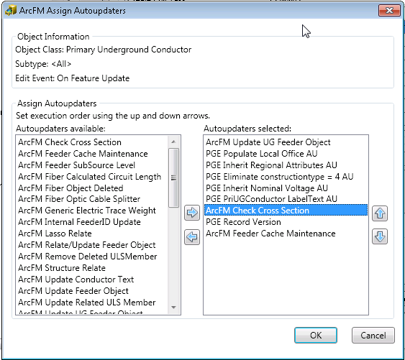

1. Select the ArcFM Check Cross Section AU from the right hand side and remove it

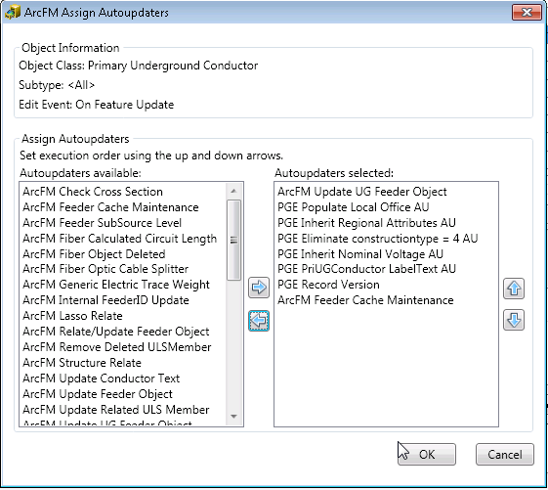

1. Click OK
2. Click OK
3. Repeat steps 1-6 for SecUGConductor and DCConductor

## 23324: Assign the Domain Installation Type to the TransformerDevice subtype Primary Connection Chamber InstallCode attribute

1. Get exclusive access to EDGIS user.
2. Right click on TransformerDevice. Select “Properties…”.
3. Add Installation Type domain to INSTALLCODE field.
4. Click Apply. Click OK.

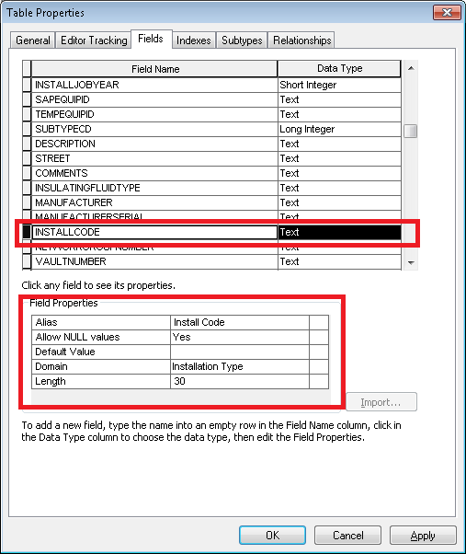

## 23356: SAPSORTFIELD needs to be made visible in TransformerDevice table

1. Open ArcCatalog
2. Right click on **TransformerDevice** table. Select "ArcFM Properties Manager".
3. Go to "Field Info" tab. Select "SAPSORTFIELD" field. Set **Visible=Yes. Editable=Yes**.



1. Click Apply. Click OK.

## Update Data Model Version Table

**Database Configuration:**

1. Open SQL Plus.
2. Log in using the same server and user as was used in section 2.1.  
     
   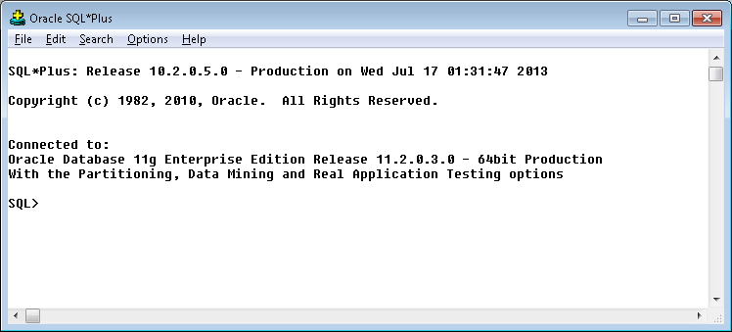
3. Run the SQL below:

update pgedatamodelversion set currentidc='N' where currentidc='Y';

insert into pgedatamodelversion (OBJECTID, CURRENTIDC, DATEAPPLIED, APPLIEDBYPERSONNAME, MODELVERSION) values (**INSERT NEXT VALID ID**,'Y',sysdate,'**<INSERT TEAM MEMBER DONE BY>**','**9.7.2** GOLD **CR<>**');

 commit;

# Known Issues

<Please List any other issues encountered here while following the document>